

**Excel Assignment - 21**

1. Write a VBA code to enter your name in A1 Cell using Input Box and once you enter the name display a message box that says the name has been entered.

**Answer –**

Sub EnterNameAndDisplayMessage()

Dim userName As String

' Prompt the user to enter their name using an Input Box

userName = InputBox("Enter your name:", "Akash Parmar")

' Check if the user entered a name

If userName <> "" Then

' Enter the name in cell A1

Range("A1").Value = userName

' Display a message box with the entered name

MsgBox "Name '" & userName & "' has been entered in cell A1.", vbInformation, "Name Entered"

Else

' If the user canceled the Input Box or did not enter a name

MsgBox "No name entered. Operation canceled.", vbExclamation, "Operation Canceled"

End If

End Sub

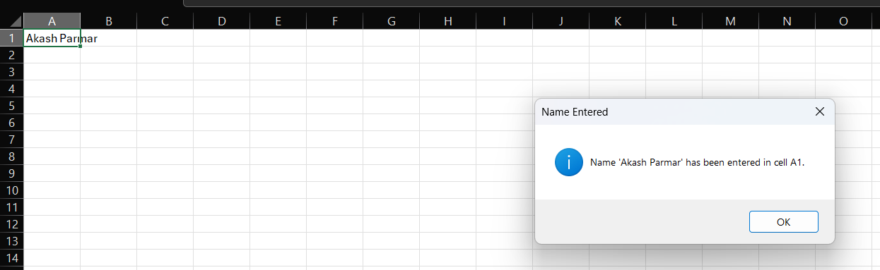

1. What are Userforms? Why are they used? How to fill a list box using for loop.

**Answer -** A UserForm in VBA is a custom dialog or form that you can create to interact with the user in Excel. It allows you to design a graphical user interface with various controls such as text boxes, buttons, checkboxes, combo boxes, and more. UserForms are commonly used to create user-friendly interfaces for data input, settings, or any other interaction within Excel.

Advantages of UserForm –

Customization, data input, user interaction, automation.

‘’’’’’’’’’’’’’’’’’’’’’’’’’’’’’’’’’’’’’’’’’’’’’’’’’’’’’’’’’’’’’

Private Sub UserForm_Initialize()

' Declare variables

Dim i As Integer

' Loop to add items to the ListBox

For i = 1 To 10

ListBox1.AddItem "Item " & i

Next i

End Sub

‘’’’’’’’’’’’’’’’’’’’’’’’’’’’’’’’’’’’’’’’’’’’’’’’’’’’’’’’’’’’’’’’’’’’’

‘Run this macro to display the UserForm with the filled ListBox.

Sub ShowUserForm()

' Show the UserForm

UserForm1.Show

End Sub

‘’’’’’’’’’’’’’’’’’’’’’’’’’’’’’’’’’’’’’’’’’’’’’’’’’’’’’’’

1. What is an array? Write a VBA code to enter students and their marks from the below table.

**Answer -** An array is a data structure in programming that allows you to store multiple values of the same data type under a single variable name. In VBA, arrays can be one-dimensional (single column or row) or multidimensional (two or more dimensions). They provide a way to efficiently manage and manipulate sets of related data.

‘’’’’’’’’’’’’’’’’’’’’’’’’’’’’’’’’’’’’’’’’’’’’’’’’’’’’’’’’’’’’’’’

Sub EnterStudentsAndMarks()

' Declare variables

Dim studentData() As Variant

Dim lastRow As Long

Dim i As Long

' Find the last row with data in column A

lastRow = Cells(Rows.Count, 1).End(xlUp).Row

' Resize the array based on the number of rows in the table

ReDim studentData(1 To lastRow, 1 To 2)

' Loop through each row and populate the array

For i = 1 To lastRow

studentData(i, 1) = Cells(i, 1).Value ' Student Name

studentData(i, 2) = Cells(i, 2).Value ' Marks

Next i

' Example: Display the array content in the Immediate Window

For i = 1 To lastRow

Debug.Print "Student: " & studentData(i, 1) & ", Marks: " & studentData(i, 2)

Next i

End Sub

1. Use the following data to create a pie chart using VBA code. Use Font - ‘Times new Roman’, Size -14, Bold, Title - Piechart’ and you are per to use colours as per your taste.

**Answer –**

Sub CreatePieChart()

Dim chartSheet As ChartObject

' Create a new chart sheet

Set chartSheet = Charts.Add

chartSheet.Chart.SetSourceData Source:=Sheets("Sheet1").Range("A1:B5"), PlotBy:=xlColumns

' Set chart properties

With chartSheet.Chart

' Chart type

.ChartType = xlPie

' Chart title

.HasTitle = True

.ChartTitle.Text = "Pie Chart"

.ChartTitle.Font.Name = "Times New Roman"

.ChartTitle.Font.Size = 14

.ChartTitle.Font.Bold = True

' Data labels

.SetElement (msoElementDataLabelCenter)

.DataLabels.Font.Name = "Times New Roman"

.DataLabels.Font.Size = 14

.DataLabels.Font.Bold = True

' Colors

.SeriesCollection(1).Points(1).Format.Fill.ForeColor.RGB = RGB(255, 0, 0) ' Red

.SeriesCollection(1).Points(2).Format.Fill.ForeColor.RGB = RGB(0, 255, 0) ' Green

.SeriesCollection(1).Points(3).Format.Fill.ForeColor.RGB = RGB(0, 0, 255) ' Blue

.SeriesCollection(1).Points(4).Format.Fill.ForeColor.RGB = RGB(255, 255, 0) ' Yellow

End With

End Sub

1. Check the dataset in the link given below and create a pivot table using VBA showing the sales for the year from stationary category.

https://docs.google.com/spreadsheets/d/1IRSEnmgz8Ro276GslknRNk0zlrB5CZH1YrnT71kqFM/edit?usp=sharing

**Answer –** File not available.

Sub CreatePivotTable()

Dim ws As Worksheet

Dim pt As PivotTable

Dim ptField As PivotField

' Set the reference to the worksheet

Set ws = ThisWorkbook.Sheets("SalesData")

' Add a new worksheet for the pivot table

Sheets.Add

ActiveSheet.Name = "PivotTableSheet"

' Set the range of the data

Set dataRange = ws.Range("A1:C100") ' Adjust the range as needed

' Create a pivot table

Set pt = ActiveSheet.PivotTableWizard(SourceType:=xlDatabase, SourceData:=dataRange, TableDestination:=Range("A1"))

' Add fields to the pivot table

Set ptField = pt.PivotFields("Year")

ptField.Orientation = xlRowField

Set ptField = pt.PivotFields("Category")

ptField.Orientation = xlRowField

ptField.Position = 2

ptField.PivotFilters.Add2 Type:=xlCaptionEquals, Value1:="Stationary"

Set ptField = pt.PivotFields("Sales")

ptField.Orientation = xlDataField

ptField.Function = xlSum

ptField.NumberFormat = "#,##0.00"

End Sub

1. Write step by step procedure to protect your workbook using a password.

**Answer –**

* Open Excel navigate to the file sections in the ribbon.
* Click on the info option.
* Then click on the protect workbook drop down.
* There will be soo many options select protect current book.
* Enter password and the access you want to give to the users.
* Click ok and the sheet is password protected.